Innovation Club Outline

This club will have 4 different stages where teams of students will compete for the best inventions to real problems.

Pre Stage – Learning to Pitch
- Students will be given extreme situations and they need to make a sales pitch.
- “Come up with something ridiculous and make us want to do it.”
  - Apple Juice (instead of milk) on cereal
  - Extreme iron boarding

Stage 1 – Incremental Innovation
- Students will select an item for a group of items to make it better.
- Items Include
  - Paperclips
  - Pens/Pencils/Stylus
  - Backpacks
  - Music Instruments

Stage 2 – Local/Global Social Issue
- Students will select a local/global social issue to solve
- They will need to;
  - Look at current solutions
  - Find problems with the current solutions
  - Invent new ways of solving that problem

Stage 3 – Environmental Problem
- Students will need to explore current environmental issues and pick one to solve.
- Environmental Issues Include (but are not limited to)
  - Energy
  - Population Size/Growth
  - Pollution
  - Sustainable Farming
  - Mineral Depletion
  - Habitat Loss/Fragmentation
  - Biodiversity Loss
  - Food

Stage 4 – Pick one from above (or new) and follow through with it

Teams
- 3 Members in a team
- Each team needs to include at least one person with a strong background in;
  - 3D Designer
  - Artist/Musician/Theatre
  - Math/Science
Mottos
Make posters and hang them on the walls that students can use as guidelines.
- ProblemCurrent Solutions Problems with Current Solution =Invention
- Incremental Innovation vs Disruptional Innovation (Venn Diagram)
- Three Components of Creativity (See Creating Innovators page 24 and 58 for more detail).
  - CULTURE: teamwork, interdisciplinary problem-solving, intrinsic incentives: exploration, play, and empowerment (me).

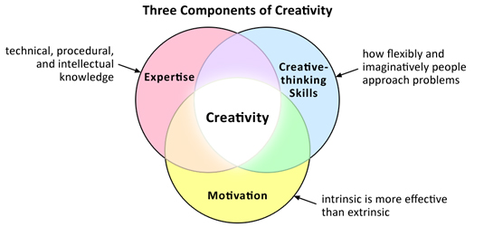
- Avoid the Feature Creep – adding to many features just because you can.

Additional Skills
- Brainstorming
- Fundraising
- Investing
- 3D design
- Coding
- Makerbots

Student Badges/Levels
- Noob
- First Runner
- First Runner Pro
- Second Runner
- Second Runner Pro
- Mentor –
- Mentor Pro – helped a team successfully run their first kickstarter
- Entrepreneur – Received VC funding

